Table of Contents

1. Acknowledgements

2. eProject Synopsis

3. eProject Analysis

4. eProject Design

* 4.1 Data Flow Diagrams (DFDs)
* 4.2 Flowcharts
* 4.3 Process Diagrams
* 4.4 Database Design / Structure

5. Screenshots

6. Source Code with Comments

7. User Guide

8. Developer’s Guide

* 8.1 Module Descriptions

1. Acknowledgements

Honorable Professors and Members of the Defense Committee,

First of all, I would like to extend my most respectful greetings and sincere gratitude to you. Today, I feel truly honored to stand here and present my graduation project to the Committee. This is an important milestone that marks my growth and development throughout the years of studying and training at the university.

During the process of carrying out this project, I had the opportunity to apply the knowledge I have learned into practice, while also facing numerous challenges and difficulties. Thanks to the dedicated guidance, valuable feedback, and timely encouragement from my professors, I was able to gain direction, motivation, and confidence to complete this project.

I would also like to sincerely thank the Committee for taking the time to listen to my presentation and for providing objective evaluations and constructive feedback. Your comments not only help me recognize the shortcomings of my project, but also serve as a precious foundation for me to continue improving, learning, and developing myself in the future.

I am fully aware that, despite my efforts, this project still has limitations and cannot avoid certain shortcomings. Therefore, I very much look forward to receiving your guidance and insightful suggestions, which will help me enhance my knowledge and apply it more effectively in practice.

Once again, I would like to express my deepest appreciation to all the professors and members of the Committee for your support, mentorship, and for creating favorable conditions for me during my studies as well as throughout the completion and defense of this project.

Thank you very much!

2. eProject Synopsis

* **Project Title:** MyCabs – A Local MVP Platform for Connecting Companies, Drivers, and Riders
* **Objective:**  
  Develop a **local-running MVP** that connects **Company – Driver – Rider** with mocked payment features. Real payment gateway integration will be implemented in **Phase 2**.
* **Tech Stack:**
* Backend: ASP.NET Core Web API (Clean Architecture), JWT + BCrypt + RBAC
* Database: MySQL
* Frontend: React (Vite) + React-Bootstrap + Toastify + Axios
* Documentation: Swagger/OpenAPI
* Realtime: SignalR
* **Main Roles & Use Cases:**
* **Admin:** Manage accounts, suspend/deactivate users, monitor membership and salaries.
* **Company:** Create profile, manage services/ads, search drivers, send invitations, approve/reject applications, manage wallet (top-up, salary payout, membership), approve/cancel rider orders.
* **Driver:** Create profile, apply to companies, accept/reject invitations, receive mock salaries, manage wallet and transactions.
* **Rider:** Browse companies/drivers, create service orders, cancel pending orders, leave 1 review per completed order (1–5 stars).
* **Business Rules:**
* **Membership:** Free / Basic / Premium; auto-downgrade when expired; 10% discount for quarterly payments.
* **Applications & Invitations:** Expire automatically after 7 days if no action.
* **Orders:** Lifecycle: Pending → InProgress → Completed/Cancelled.
* **Wallet & Transactions:** Must remain ≥ 0; warnings at balance < 10000; low balance blocks some actions (salary payout, new invites, ads, upgrades).
* **Notifications:** SignalR events (InviteCreated, ApplicationSubmitted, OrderStatusChanged, WalletLowBalance, MembershipExpired).
* **Deliverables:**
* Architecture & ERD diagrams
* API specifications (OpenAPI/Swagger)
* Seed data (3 Companies, 6 Drivers, 5 Services, 5 Riders, 10 Orders)
* Backend/Frontend skeleton code + local run scripts
* Demo flows:
  1. Company invites Driver
  2. Driver applies to Company
  3. Rider creates Order → Completed → Review
* **Acceptance Criteria:**
* Local system runs successfully (FE + BE)
* FE can call at least 3 main API groups (Auth, Company, Driver)
* Demo flows run smoothly with seeded data

3. eProject Analysis

**📊 EProject Analysis – MyCabs MVP**

**1. Problem Statement**

Currently, the demand for connecting **transportation service companies (Companies)**, **drivers (Drivers)**, and **riders (Riders)** is increasing. However:

* Recruitment, collaboration invitations, and salary payouts are still manual and lack transparency.
* Riders struggle to find reliable companies and evaluate drivers effectively.
* There is no **local-running MVP platform** to test this model before real-world deployment with a payment gateway.

**2. Project Objective**

* Build a **local MVP platform** to connect **Company – Driver – Rider**.
* Implement key business processes: registration, application, invitations, service orders, wallet & transactions, membership.
* Payment is mocked in **Phase 1** → real payment gateway will be integrated in **Phase 2**.
* Support **Admin role** to manage users, memberships, and monitor the system.

**3. Stakeholders**

* **Admin:** Manage the entire system, user accounts, memberships, and salaries.
* **Company Owner:** Create profile, manage services & advertisements, handle wallet & transactions, invite drivers, approve/reject applications, approve/cancel orders.
* **Driver:** Create profile, apply to companies, accept/reject invitations, receive salaries, view wallet & transaction history.
* **Rider:** Browse companies/drivers, create service orders, cancel pending orders, leave reviews after completion.

**4. System Scope**

✅ **In-Scope (MVP Phase 1):**

* Registration/Login with Email OTP.
* Company: profile, services/ads, wallet, orders.
* Driver: applications, accept/reject invitations.
* Rider: create orders & reviews.
* Admin: account management, membership monitoring, reports.
* Mock wallet & transactions (top-up, salary, membership).
* Realtime notifications via SignalR.

❌ **Out-of-Scope (Phase 1):**

* Maps, routing, and real payment gateway.
* Logging/audit, internationalization (i18n).

**5. Business Rules**

* **Membership:** Free = 1 service, Basic = 3, Premium = unlimited; auto-downgrade on expiry; 10% discount for quarterly payments.
* **Applications & Invitations:** {Applied, Accepted, Rejected}, auto-expire after 7 days.
* **Orders:** Lifecycle = Pending → InProgress → Completed/Cancelled; Rider can cancel only when Pending.
* **Wallet & Transactions:** Balance must always ≥ 0; low-balance threshold = 10000; when balance <10000, block critical actions (sending invites, accepting applications, paying salaries, creating/reactivating ads).
* **Notifications:** Delivered via SignalR for events: InviteCreated, ApplicationSubmitted, OrderStatusChanged, WalletLowBalance, MembershipExpired.

**6. Functional Requirements**

* **Auth:** OTP verification, Login, JWT-based authentication, Role-based access control.
* **Rider:** Browse companies/drivers, create service orders, submit reviews.
* **Driver:** Create/update profile, apply to companies, accept/reject invitations, view wallet.
* **Company:** Manage profile, create services/ads, handle applications & invitations, manage wallet, pay salaries, pay membership, manage orders.
* **Admin:** Manage accounts, suspend/deactivate users, monitor memberships & salaries, generate system reports.
* **Notification System:** Realtime updates for invitations, applications, orders, wallet status, and membership expiry.

**7. Non-Functional Requirements**

* Server-side search/filter/sort/pagination.
* Email OTP for sign-up & password reset.
* Soft delete with isActive=false.
* UTC timezone handling.
* No i18n/logging/audit in MVP phase.

**8. Deliverables**

* **Documents:** Architecture diagram, ERD, API specification (OpenAPI/Swagger).
* **Seed Data:** 3 Companies, 6 Drivers, 5 Services, 5 Riders, 10 Orders.
* **Codebase:** Backend & Frontend skeletons with seed scripts.
* **Demo Flows:**
  1. Company invites Driver.
  2. Driver applies to Company.
  3. Rider creates order → Completed → Review.

4.eProject Design

4.1. Data Flow Diagrams (DFDs)

**DFDs (Data Flow Diagrams)**

**1) Overview**

This section models how data moves through **MyCabs MVP**: between external actors (Rider, Driver, Company, Admin, OTP/Email, Mock Payment) and internal processes, plus the persistent data stores. We provide a **Context (Level-0) DFD** and a **Level-1 decomposition** into core processes.

**2) Notation (legend)**

* **External Entity**: actors outside the system (square)
* **Process**: business function that transforms data (rounded rectangle)
* **Data Store**: persistent storage (open-ended rectangle, labeled D#)
* **Data Flow**: labeled arrow showing data in motion

**3) Context Diagram (Level-0) — “MyCabs System”**

**External Entities**

* **E1 – Rider**
* **E2 – Driver**
* **E3 – Company (Owner)**
* **E4 – Admin**
* **E5 – Email/OTP Provider**
* **E6 – Mock Payment Gateway**

**Central Process**

* **P0 – MyCabs System**

**Key Data Flows**

* E1 ⇄ P0: *Browse Companies/Drivers, Create Orders, Reviews, Auth/OTP*
* E2 ⇄ P0: *Profile, Applications, Invitations, Wallet view, Auth/OTP*
* E3 ⇄ P0: *Services/Ads, Search Drivers, Applications, Invitations, Orders approval/cancel, Wallet ops*
* E4 ⇄ P0: *Account mgmt, Deactivate/Suspend, Reports/Dashboards*
* P0 ⇄ E5: *Send/Verify OTP emails*
* P0 ⇄ E6: *Top-up/Membership/Salary (mock) results*

**Core Data Stores (inside P0)**

* **D1 Users & Accounts** (users, roles, auth)
* **D2 Profiles** (Driver, Company)
* **D3 Services & Ads**
* **D4 Orders**
* **D5 Applications** (Driver→Company)
* **D6 Invitations** (Company→Driver)
* **D7 Wallets**
* **D8 Transactions** (top-up, salary, membership)
* **D9 Reviews** (post-completion, immutable)
* **D10 Notifications** (push backlog)
* **D11 Memberships** (plan, status, expiry)
* **D12 Deactivations/Suspensions** (reason, scope, expiresAt)

**4) Level-1 DFD (Decomposition)**

**P1 – Auth & Account**

* **Inputs:** Register/Login requests, OTP request/verify, Profile updates
* **Outputs:** JWT token + profile, OTP emails, success/error
* **Data Stores:** D1 Users & Accounts, D2 Profiles
* **Flows:**
  + User → P1: *register/login/otp* → P1 → E5 (send OTP) / D1 (create/verify)
  + P1 → User: *JWT {accessToken, profile}*

**P2 – Rider Orders & Reviews**

* **Inputs:** Create Order, Cancel (Pending), Review after Completed
* **Outputs:** Order status updates, Review persisted
* **Data Stores:** D3 Services, D4 Orders, D9 Reviews, D10 Notifications
* **Flows:**
  + Rider → P2: *create order* → D4
  + Company/Admin → P2: *confirm → InProgress / complete / cancel* → D4
  + Rider → P2: *review (1–5, immutable)* → D9
  + P2 → Notifications: *OrderStatusChanged*

**P3 – Driver Applications & Company Invitations**

* **Inputs:** Apply (Driver→Company), Invite (Company→Driver), Accept/Reject
* **Outputs:** Collaboration established/declined/expired
* **Data Stores:** D5 Applications, D6 Invitations, D10 Notifications
* **Rules:** Auto-expire after 7 days
* **Flows:**
  + Driver → P3: *apply* → D5
  + Company → P3: *invite* → D6
  + Driver/Company → P3: *accept/reject* → D5/D6
  + P3 → Notifications: *ApplicationSubmitted, InviteCreated*

**P4 – Company Services, Ads & Orders Control**

* **Inputs:** CRUD Services/Ads, Approve/Cancel Orders
* **Outputs:** Updated listings, order decisions
* **Data Stores:** D3 Services & Ads, D4 Orders, D11 Memberships
* **Rules:** Membership quota (Free=1, Basic=3, Premium=∞); lock premium features on expiry/downgrade

**P5 – Wallet & Transactions (Mock Payments)**

* **Inputs:** Top-up, Pay Salary, Pay Membership
* **Outputs:** Transaction result (Pending/Completed/Failed), balance changes
* **Data Stores:** D7 Wallets, D8 Transactions, D11 Memberships, D10 Notifications
* **External:** E6 Mock Payment Gateway
* **Rules:** No negative balance; warning threshold 10000; idempotency for top-up/payroll
* **Flows:**
  + Company → P5: *top-up/pay salary/membership* → E6 (mock) → result
  + P5 → D7/D8 update; P5 → D11 (extend plan)
  + P5 → Notifications: *WalletLowBalance*

**P6 – Membership Lifecycle**

* **Inputs:** Purchase/renew, expiry scheduler
* **Outputs:** Active/Expired states, auto-downgrade
* **Data Stores:** D11 Memberships, D3 Services/Ads (pause), D10 Notifications
* **Rules:** 10% discount quarterly; auto-pause premium features on expiry

**P7 – Admin Management & Reports**

* **Inputs:** Search/filter/sort/paginate; Deactivate/Suspend; Force-downgrade
* **Outputs:** Status changes, dashboards
* **Data Stores:** D1, D2, D3, D4, D5, D6, D7, D8, D11, D12, D10
* **Flows:** Admin → P7 → (writes to) D12 Deactivations; (reads) all D# for reports

**P8 – Notifications (Realtime & Backlog)**

* **Inputs:** Events from P2–P7
* **Outputs:** SignalR pushes; unread counts
* **Data Stores:** D10 Notifications
* **External:** Clients via SignalR
* **Events:** InviteCreated, ApplicationSubmitted, OrderStatusChanged, WalletLowBalance, MembershipExpired

**5) Data Dictionary (key stores – brief)**

* **D1 Users & Accounts**: id, email, passwordHash, role{Admin|Company|Driver|Rider}, isActive, createdAt
* **D2 Profiles**: driver{phone,bio,skills,location}, company{name,description,address}
* **D3 Services & Ads**: serviceId, companyId, type, title, basePrice, status{active|paused}, quota
* **D4 Orders**: orderId, riderId, companyId, serviceId, status{Pending|InProgress|Completed|Cancelled}, timestamps
* **D5 Applications**: appId, driverId, companyId, status{Applied|Accepted|Rejected|Expired}, expiresAt
* **D6 Invitations**: inviteId, companyId, driverId, baseSalary, status{Created|Accepted|Rejected|Expired}, expiresAt
* **D7 Wallets**: ownerType{Company|Driver|Rider|Admin}, ownerId, balance
* **D8 Transactions**: txId, walletId, type{Topup|Salary|Membership}, amount, status{Pending|Completed|Failed}, idempotencyKey
* **D9 Reviews**: reviewId, orderId, riderId, rating[1..5], comment, immutable=true
* **D10 Notifications**: notifId, userId, type, payload, isRead
* **D11 Memberships**: companyId, plan{Free|Basic|Premium}, paidUntil, autoDowngraded
* **D12 Deactivations/Suspensions**: targetType, targetId, reasonCode, scope, expiresAt|null

**6) Balancing & Assumptions**

* **Balancing:** All external flows in the Context DFD appear in Level-1, and child processes collectively preserve inputs/outputs of P0.
* **Assumptions:**
  + OTP handled via external provider; only tokens/reference stored locally.
  + Payment is **mocked**; gateway returns deterministic Pending/Success/Fail.
  + Reviews are **write-once** per completed order.
  + Low-balance < 10000 triggers blocks defined in business rules.

**7) Security & Integrity Notes**

* JWT for auth; role claims for authorization.
* Idempotency on payment-like operations.
* No negative wallet balances; referential integrity on all foreign keys.
* Expiry jobs enforce 7-day auto-expire for Applications/Invitations and auto-downgrade for Memberships.

4.2 Flowcharts

1. Rider_Order_Flow_gv

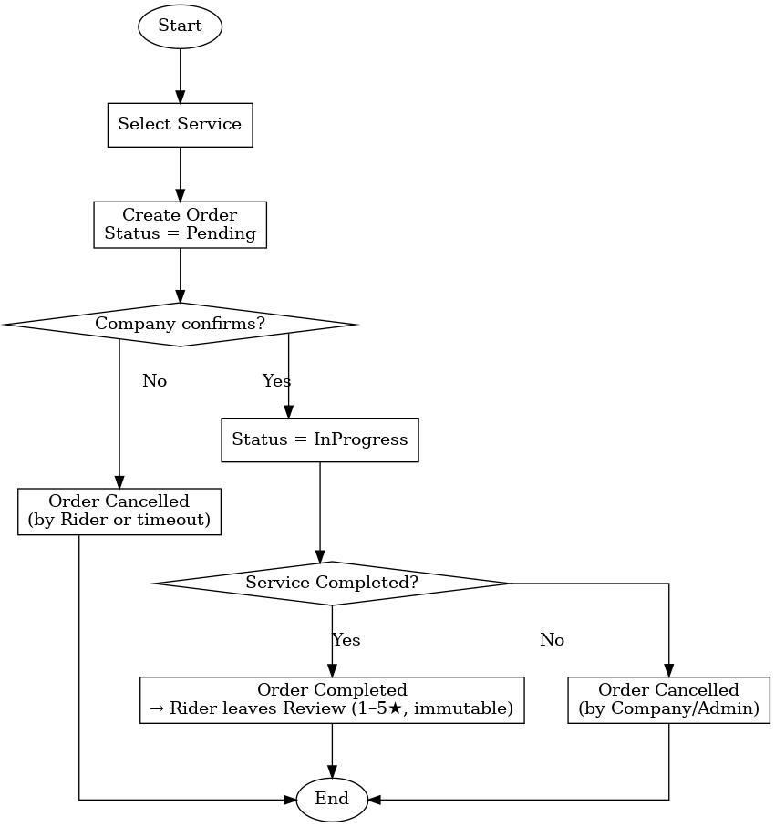

2. Driver_App_Invite_Flow_gv

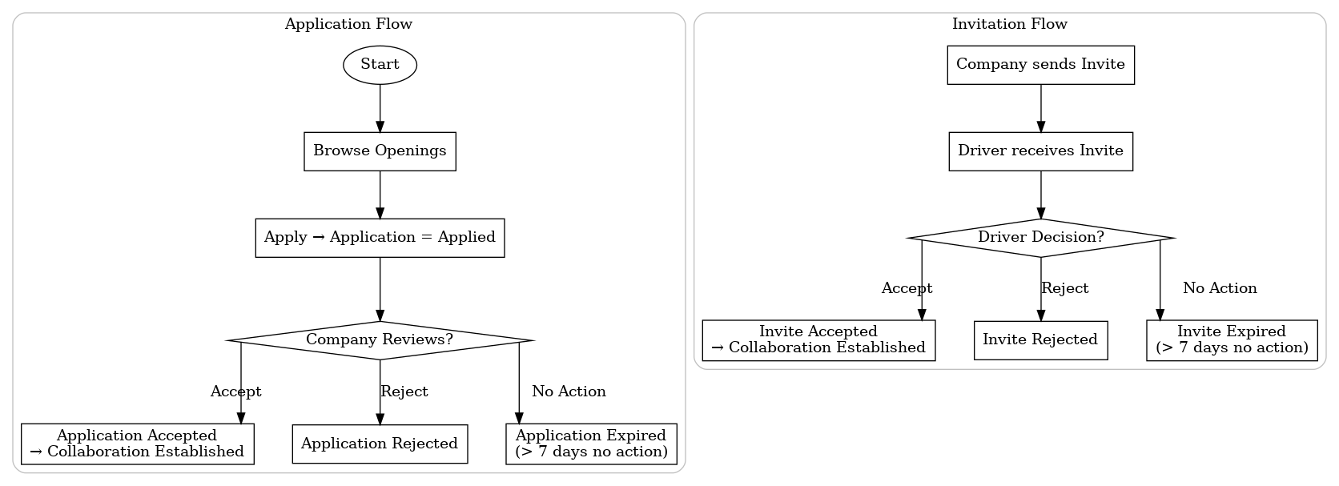

3. Company_Wallet_Flow_gv

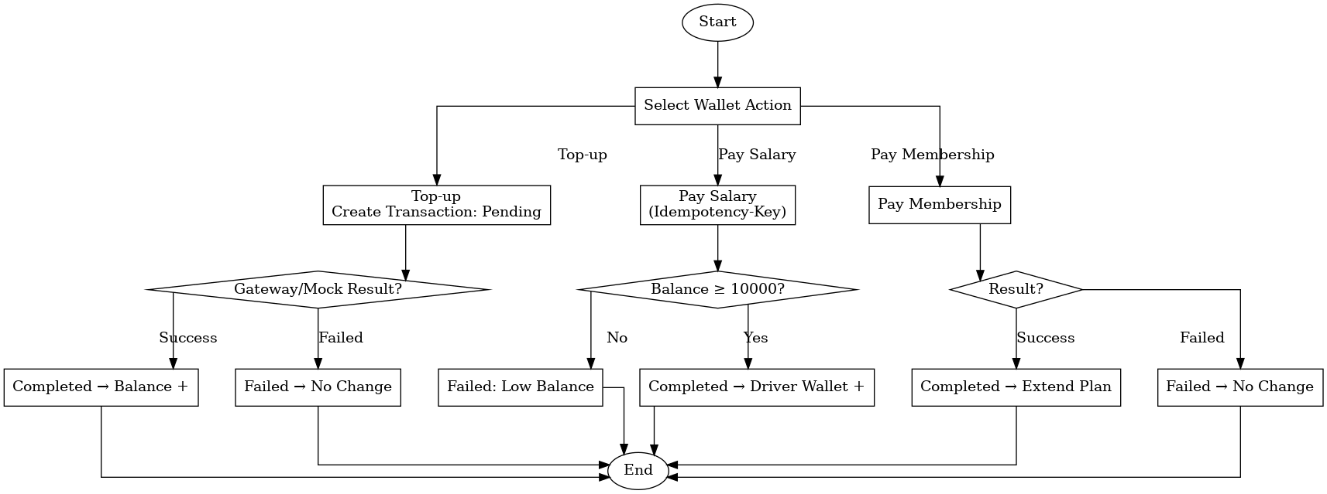

4. Admin_Account_Management_Flow_gv

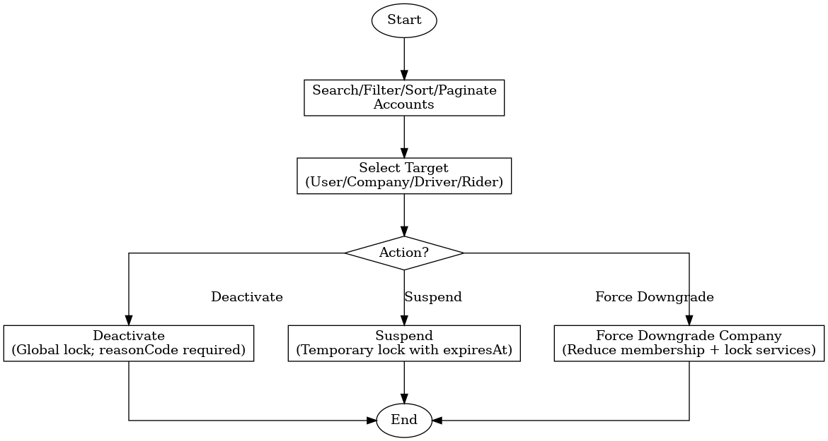

5. Membership_Lifecycle_Flow_gv

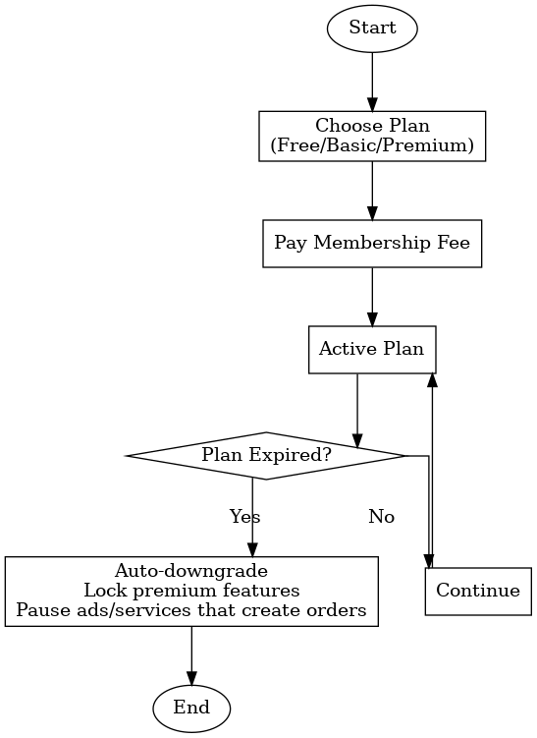

4.3.Process Diagrams

**🔄 Process Diagrams – MyCabs MVP**

**1. Authentication & Account Management Process**

**Actors:** Rider, Driver, Company, Admin, Email/OTP Provider  
**Steps:**

1. User registers an account → system stores in **Users & Accounts (D1)**.
2. System requests OTP from **Email Provider**.
3. User verifies OTP → system activates account.
4. On login → user submits credentials → system returns **JWT accessToken + profile**.
5. User can update profile (Driver: phone, bio; Company: name, description, address).  
   **Process Diagram:**

* Start → Register/Login → OTP Request/Verify → Token Issued → Access System

**2. Rider Order & Review Process**

**Actors:** Rider, Company, Admin  
**Steps:**

1. Rider selects a Company’s service → creates new **Order** (status = Pending).
2. Company reviews order:
   * If confirmed → status = InProgress.
   * If rejected → status = Cancelled.
3. After service completion:
   * Company marks as Completed.
   * Rider may submit one **Review (1–5★ + comment)**.
4. Notifications are pushed at each status change.  
   **Process Diagram:**

* Rider: Create Order → Pending → Company Confirms? → (Yes: InProgress / No: Cancelled) → Completed → Rider leaves Review.

**3. Driver Application & Company Invitation Process**

**Actors:** Driver, Company  
**Application Flow:**

1. Driver browses job openings → applies → **Application=Applied**.
2. Company reviews:
   * Accept → Application=Accepted → Collaboration created.
   * Reject → Application=Rejected.
   * No action after 7 days → Application=Expired.

**Invitation Flow:**

1. Company sends **Invitation** to Driver.
2. Driver decides:
   * Accept → Collaboration established.
   * Reject → Invite Rejected.
   * No action after 7 days → Invite Expired.

**4. Company Wallet & Transaction Process**

**Actors:** Company, Mock Payment Gateway, Admin, Drivers  
**Steps:**

1. Company performs wallet actions:
   * **Top-up** → Transaction=Pending → Payment Gateway → Completed/Failed.
   * **Pay Salary** → Check balance ≥ 10000? If yes, Transaction Completed (Driver Wallet+). If no, Failed.
   * **Pay Membership** → Similar check & update membership.
2. Transactions are logged in **Transactions Store (D8)**.
3. Low balance (<10000) triggers **WalletLowBalance Notification**.

**5. Membership Lifecycle Process**

**Actors:** Company, System Scheduler  
**Steps:**

1. Company chooses plan (Free, Basic, Premium).
2. Pays fee → Membership activated.
3. Membership valid until **expiry date**.
4. On expiry → system auto-downgrades to Free, pauses ads/services, and sends **MembershipExpired Notification**.

**6. Admin Account Management Process**

**Actors:** Admin, All Users  
**Steps:**

1. Admin searches/filters/sorts users.
2. Selects target: Company / Driver / Rider.
3. Chooses action:
   * **Deactivate** → lock account permanently (reasonCode required).
   * **Suspend** → lock temporarily with expiresAt.
   * **Force Downgrade** → reduce Company membership & pause services.
4. Changes are logged in **Deactivation/Suspension Store (D12)**.

4.4 Database Design / Structure

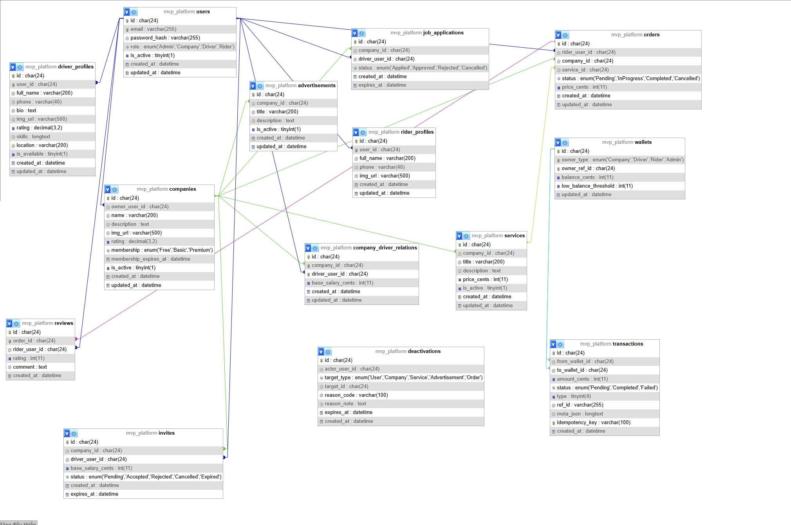

5.Screenshots

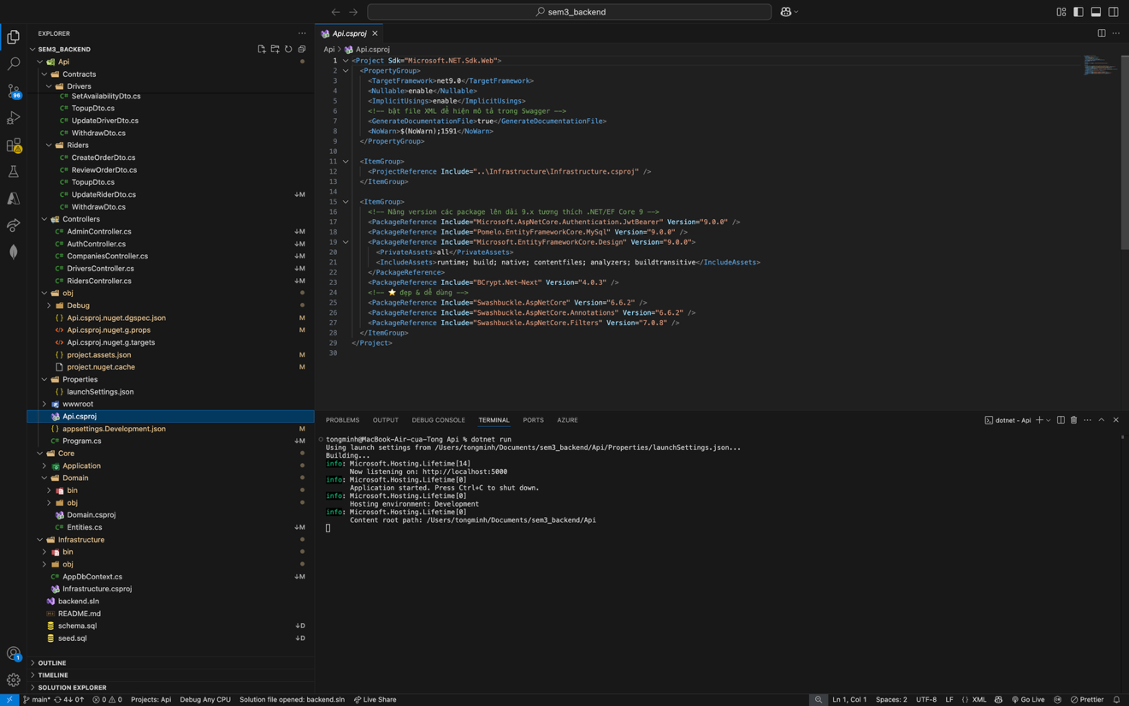

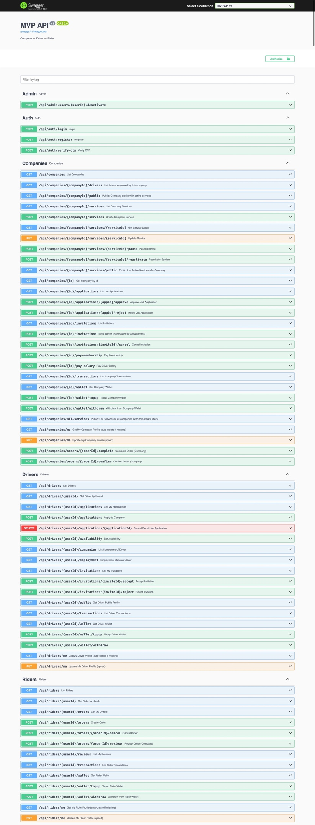

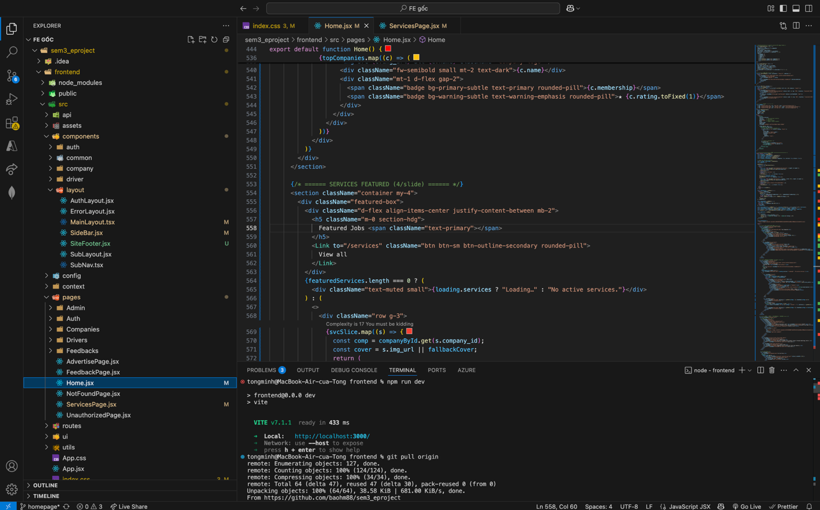

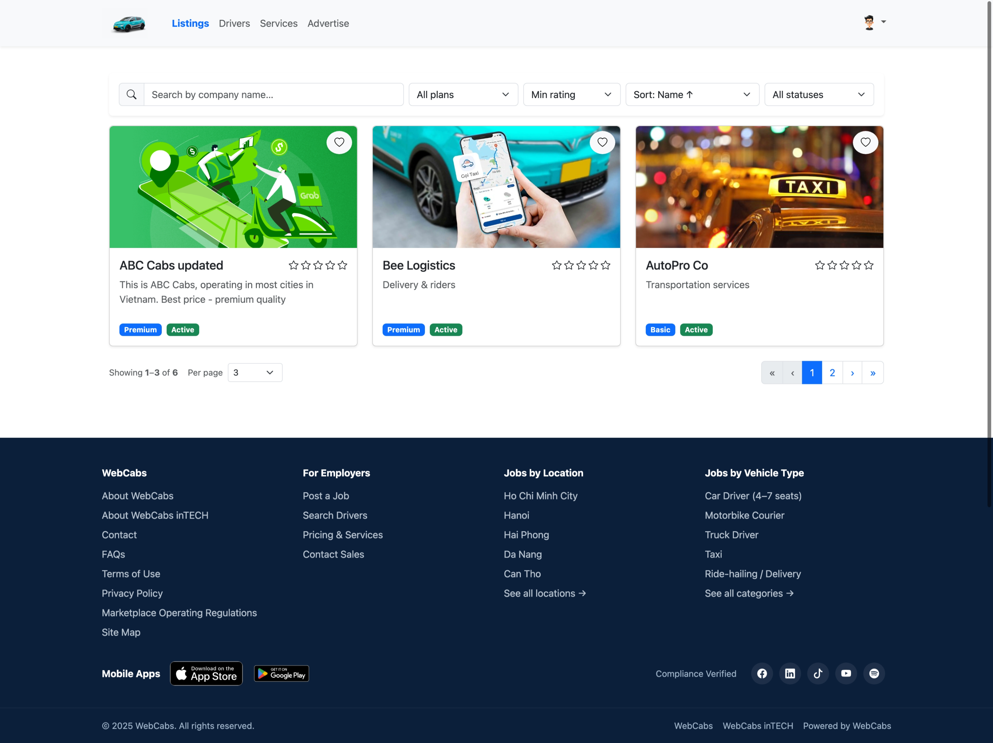

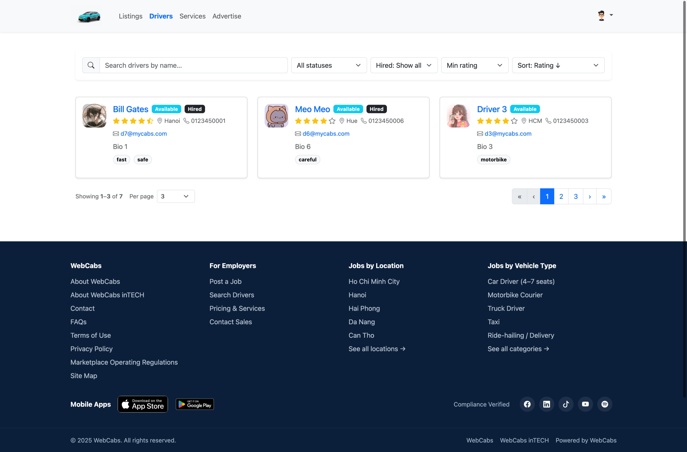

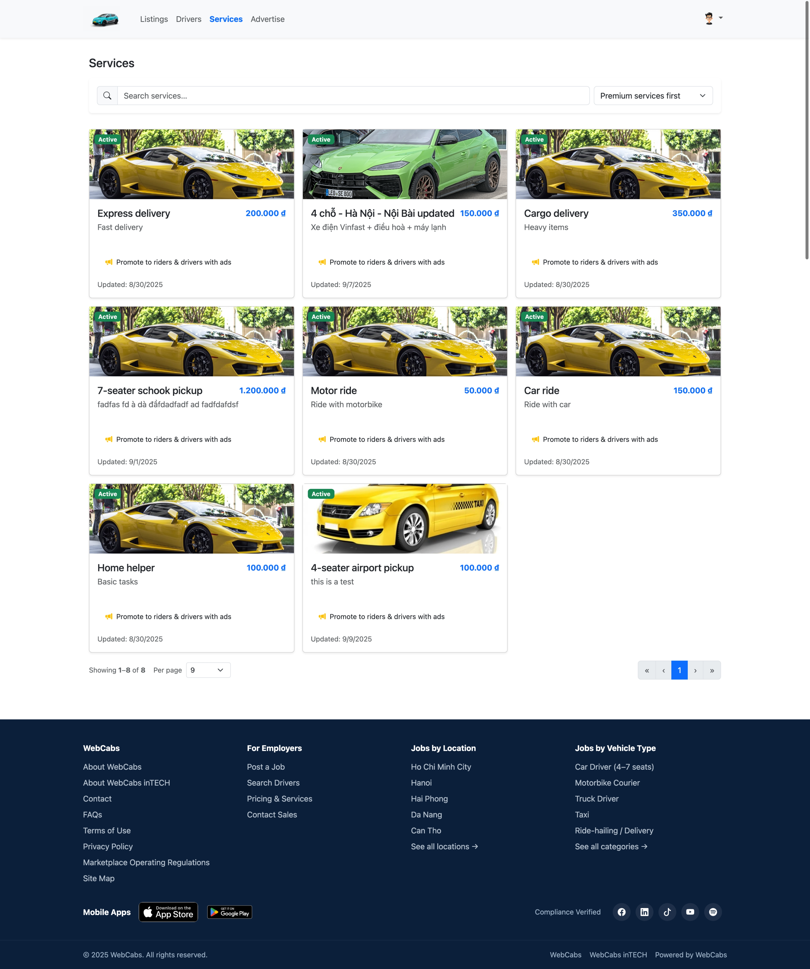

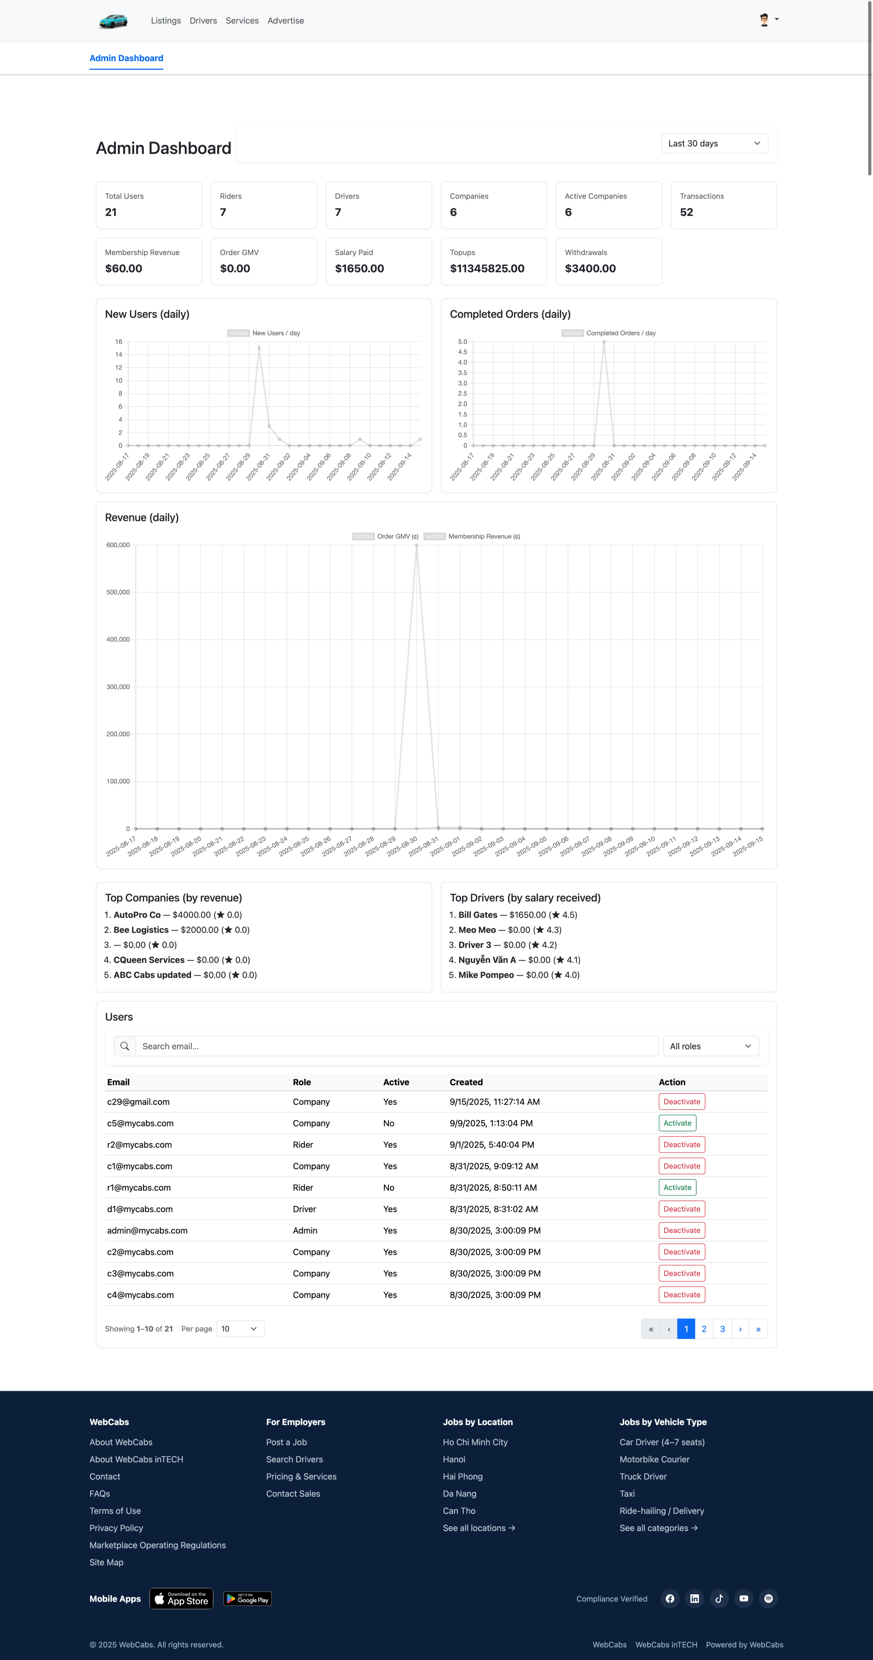

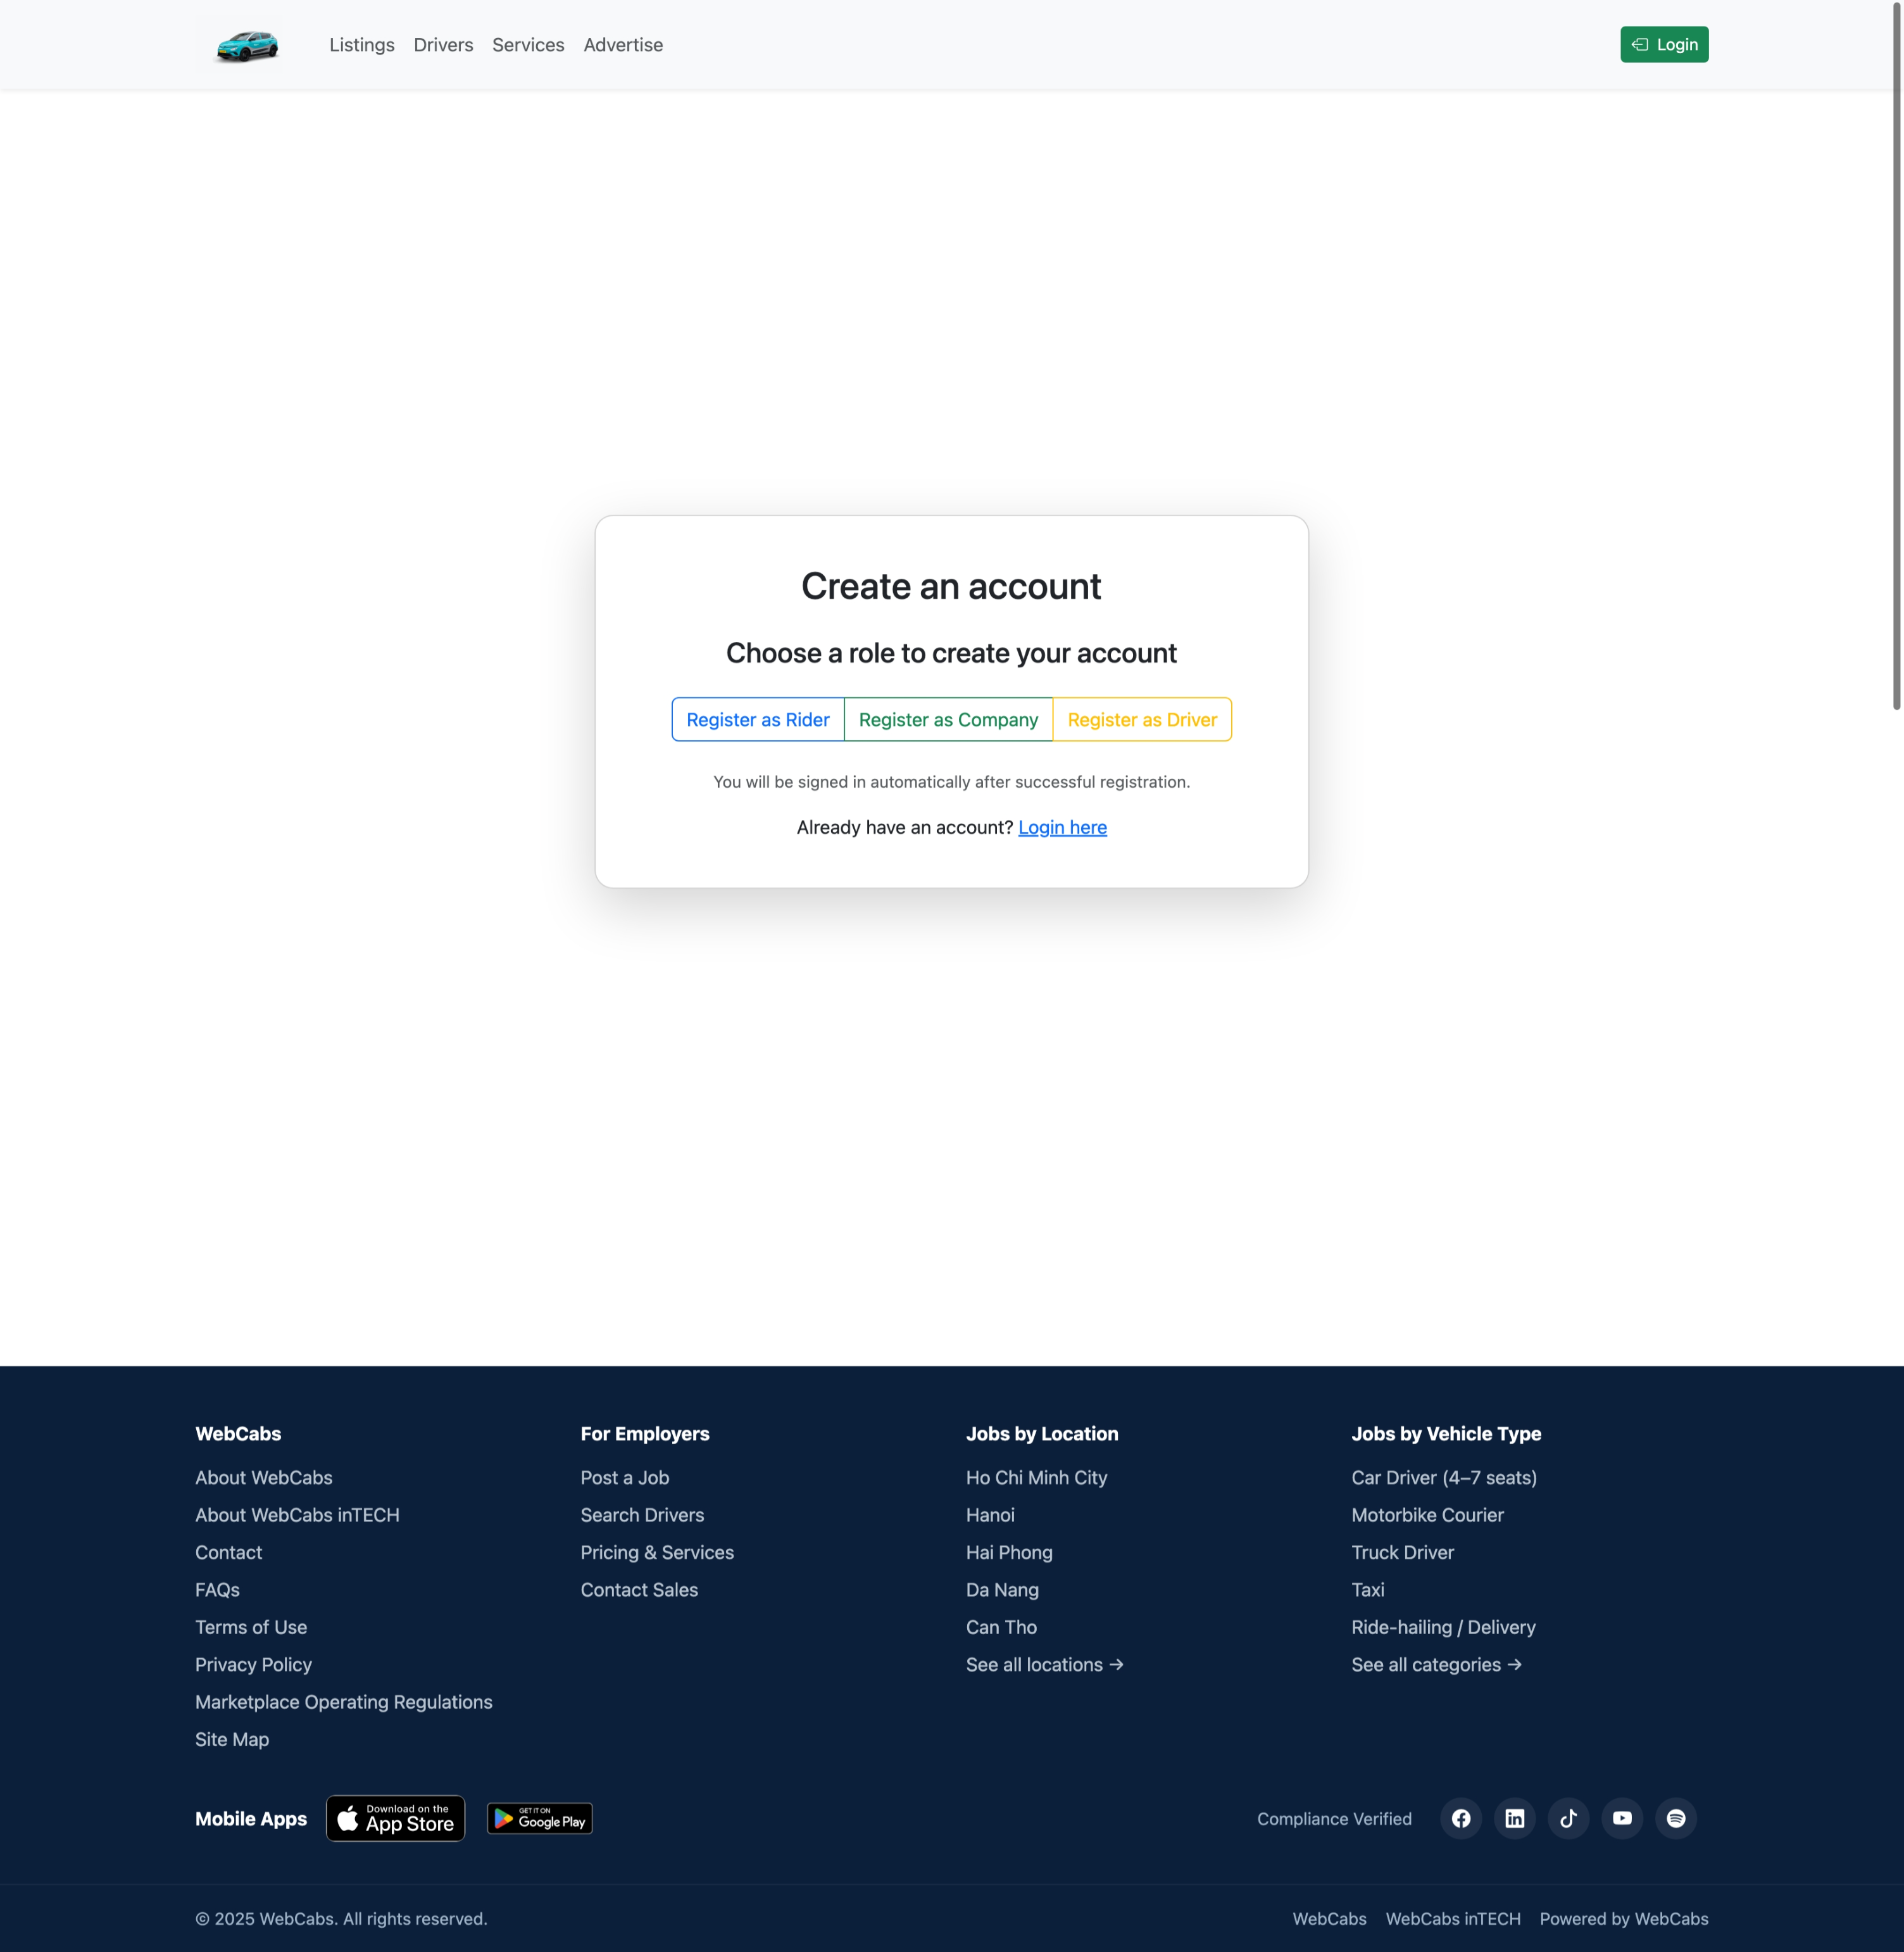

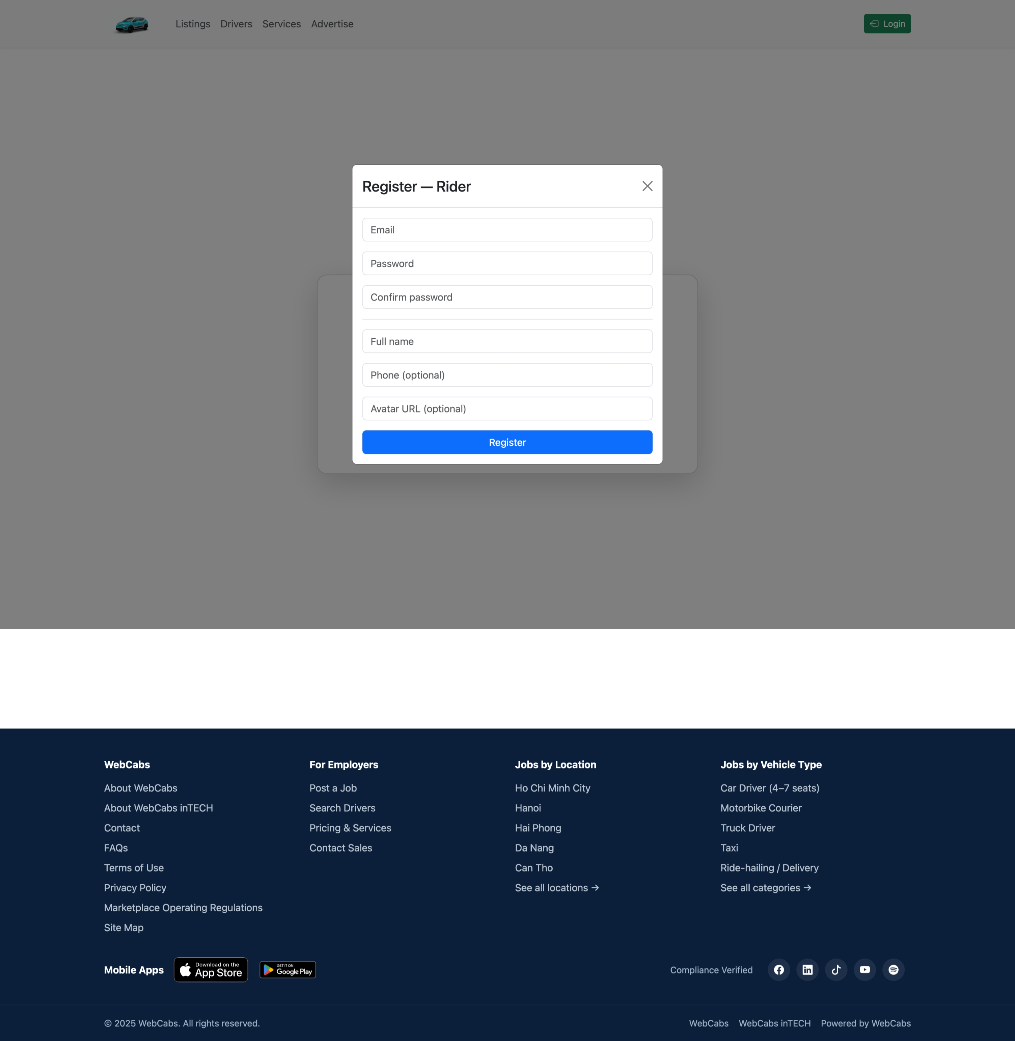

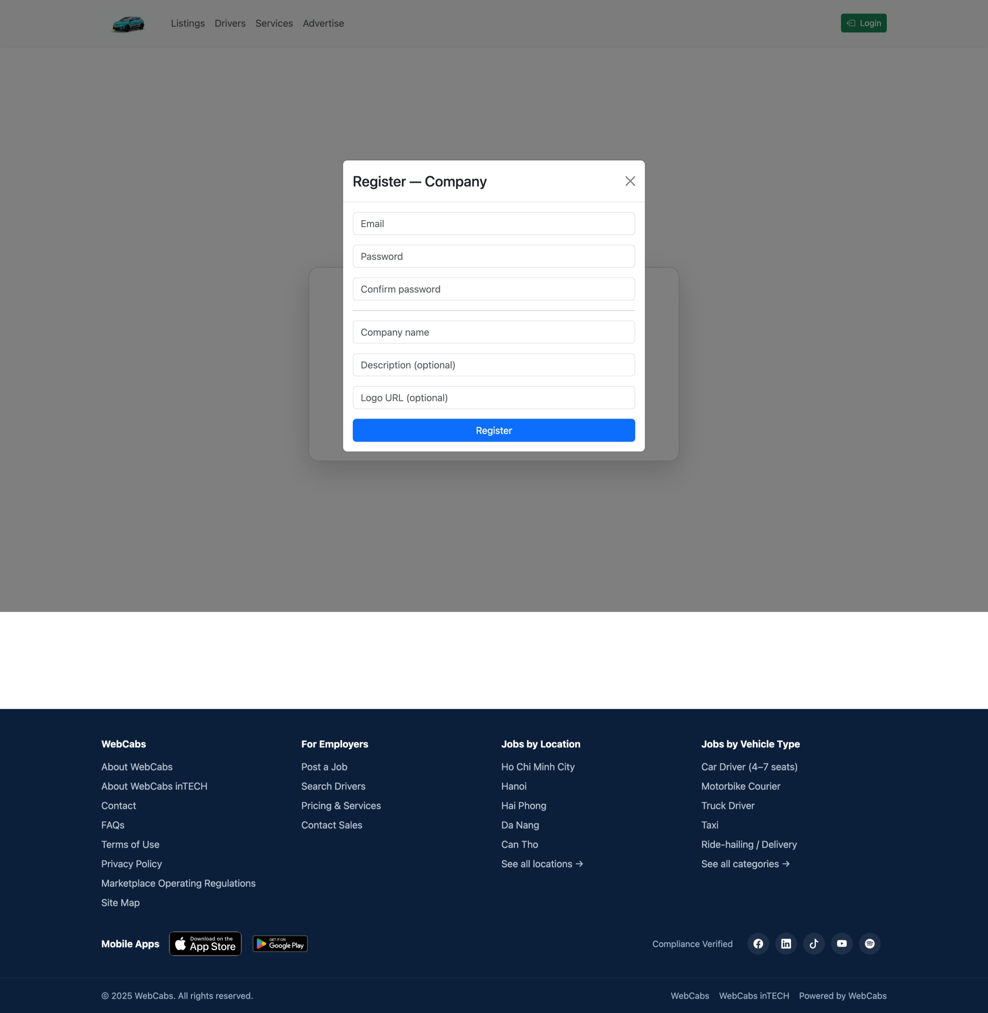

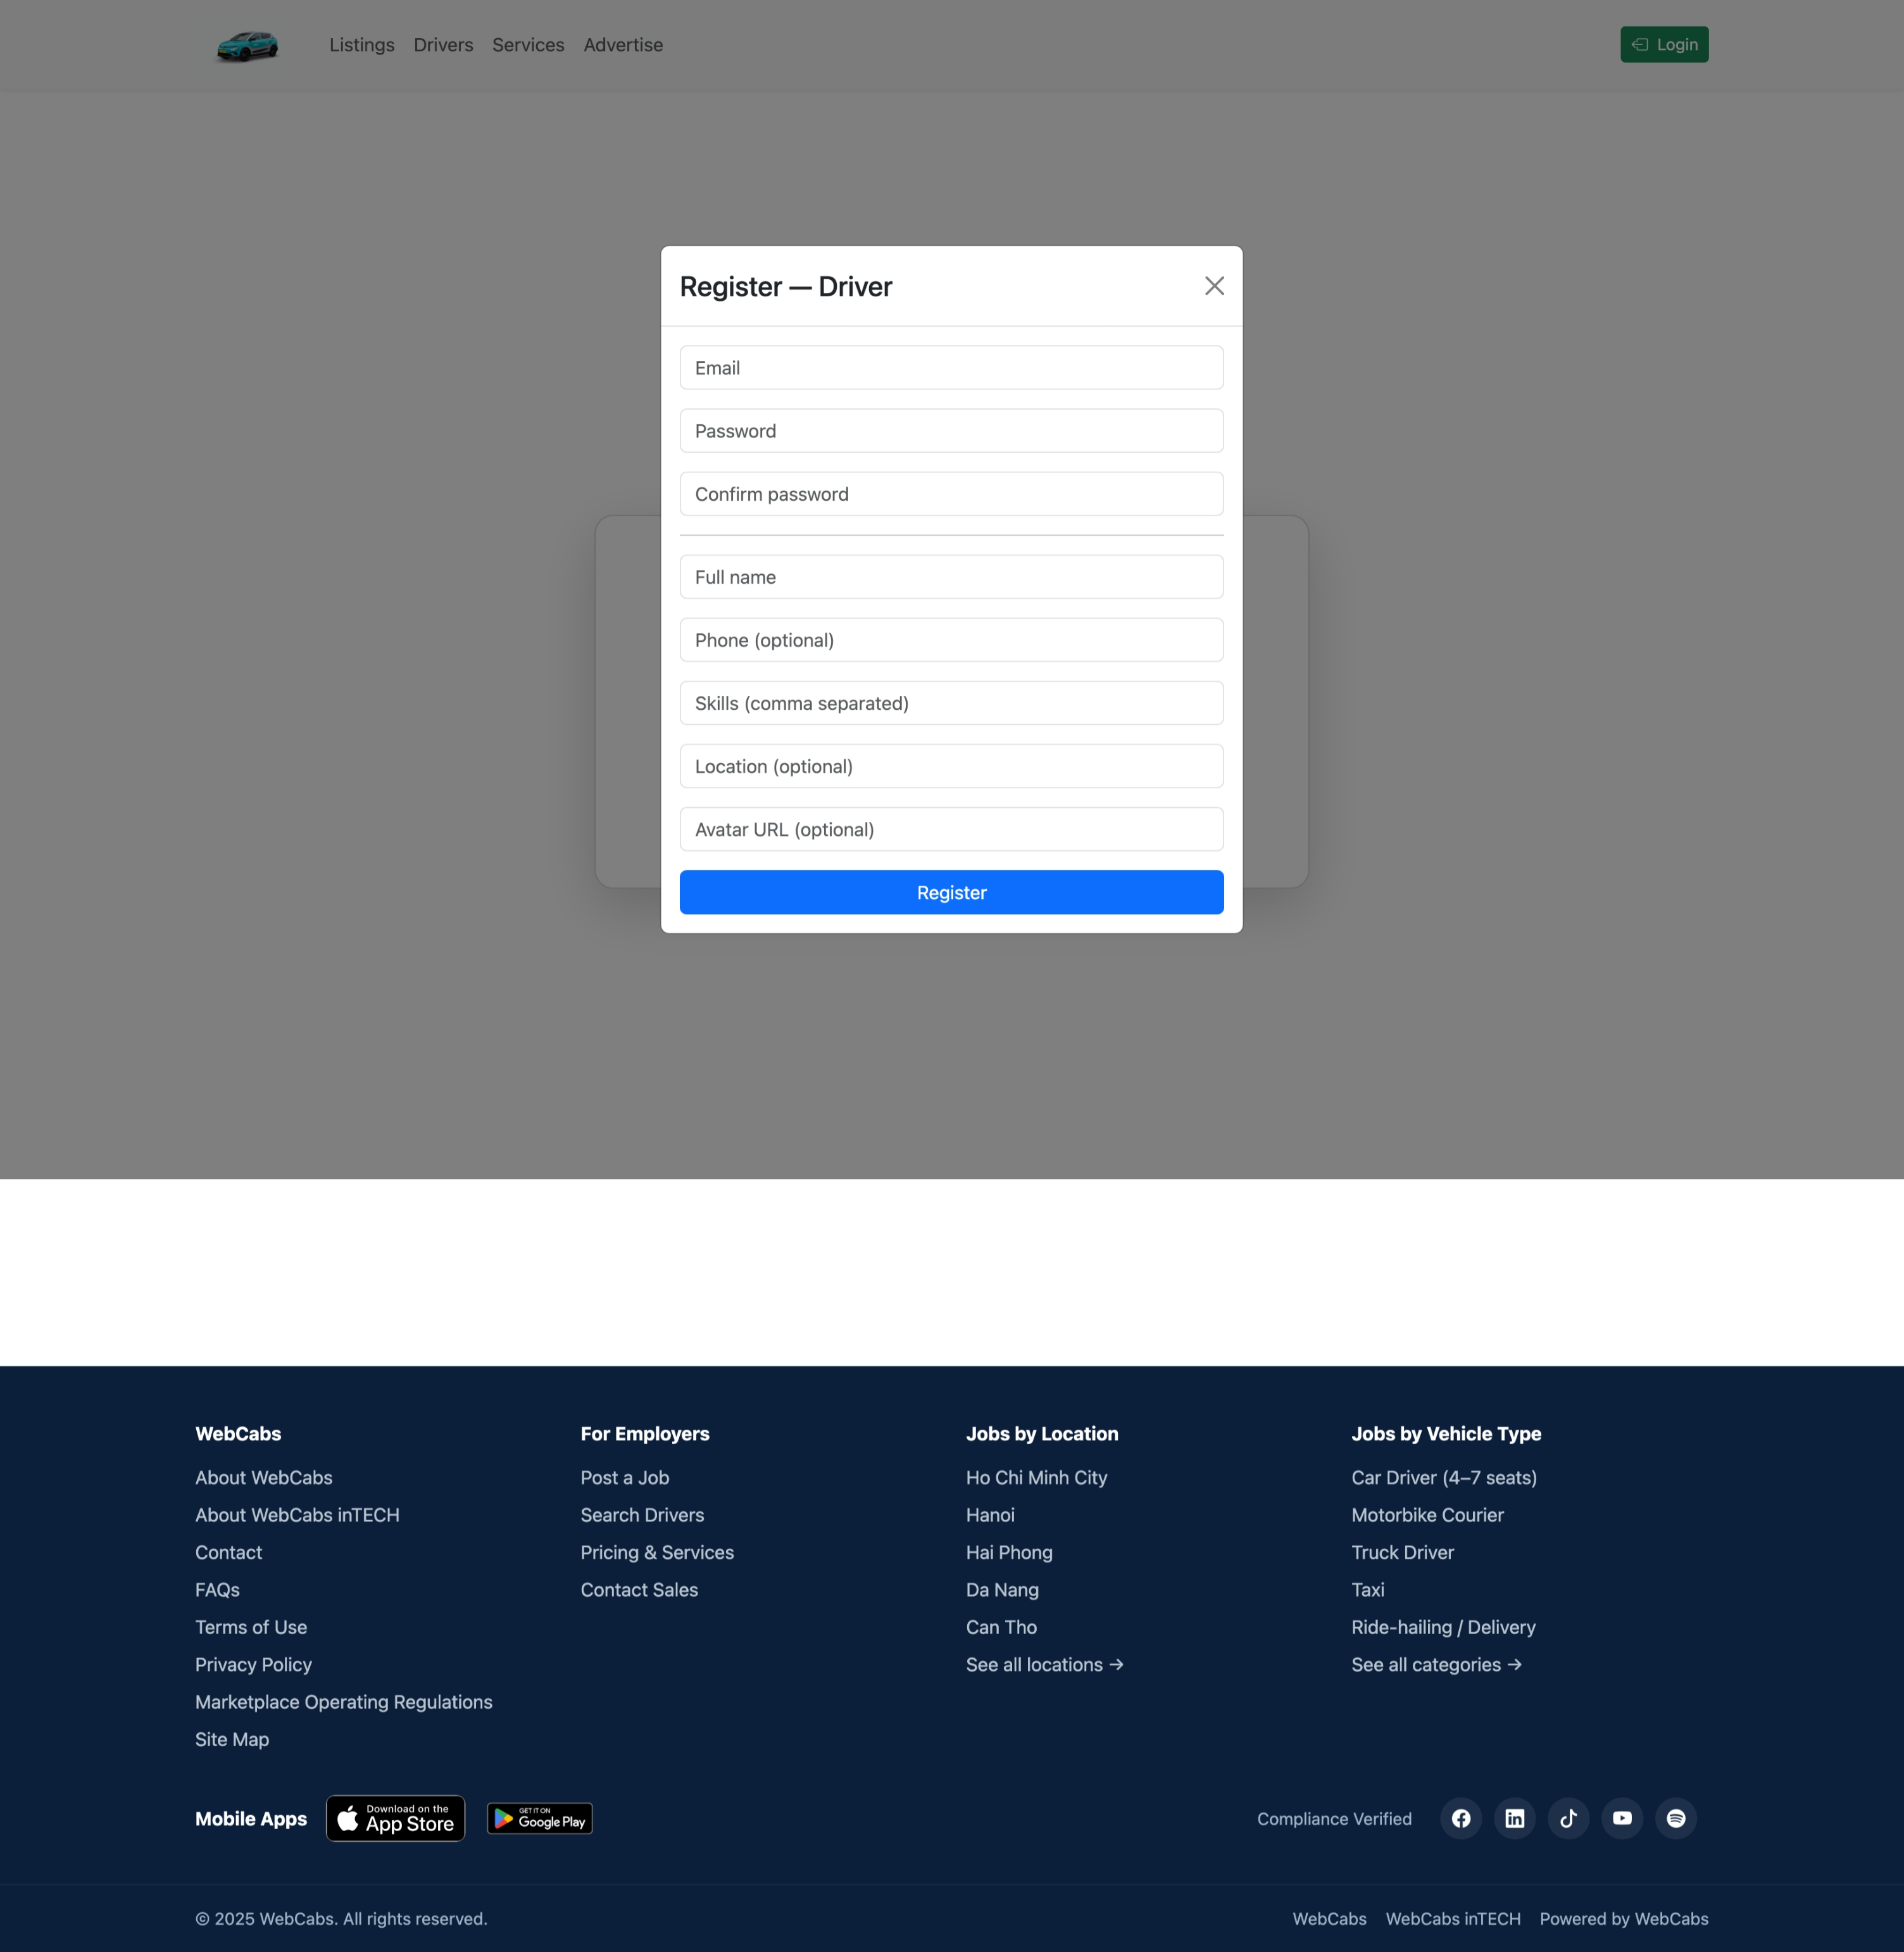

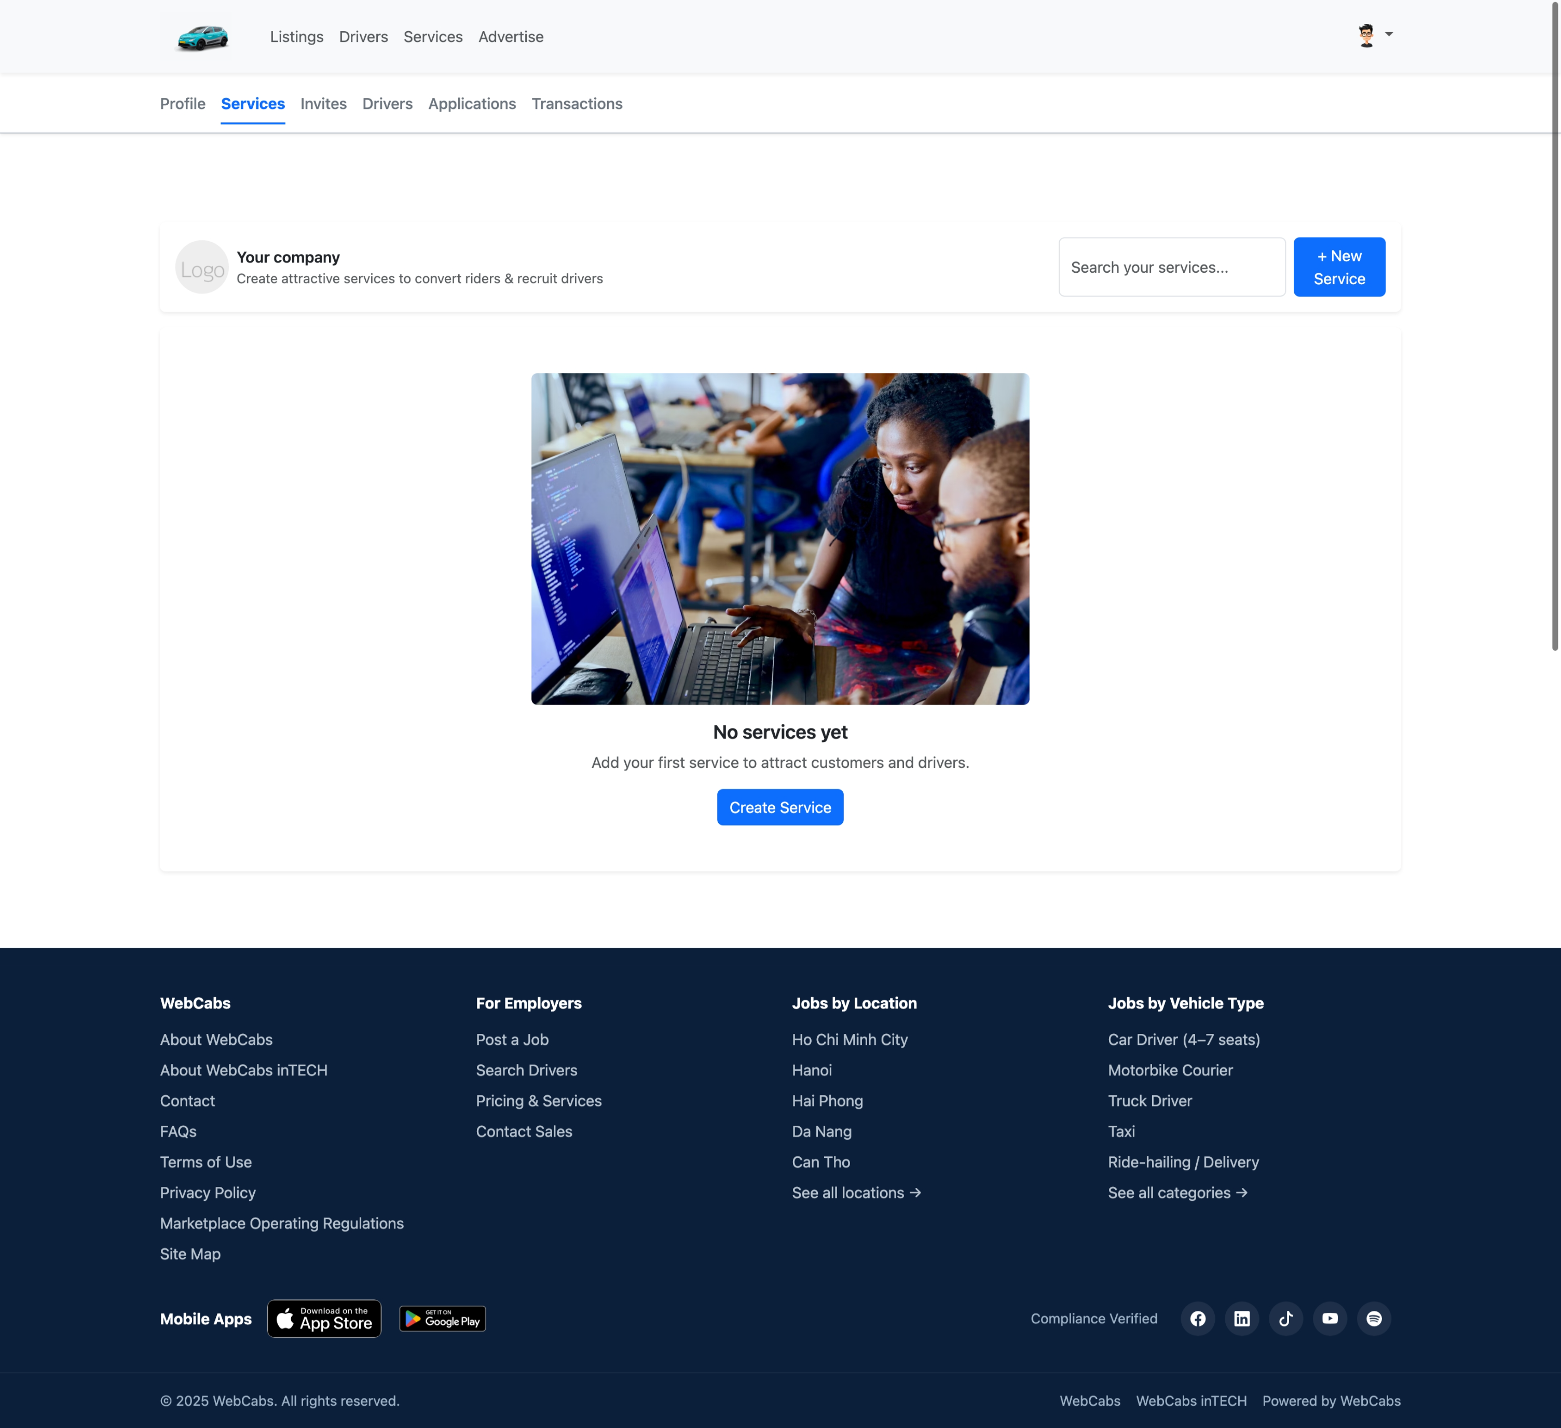

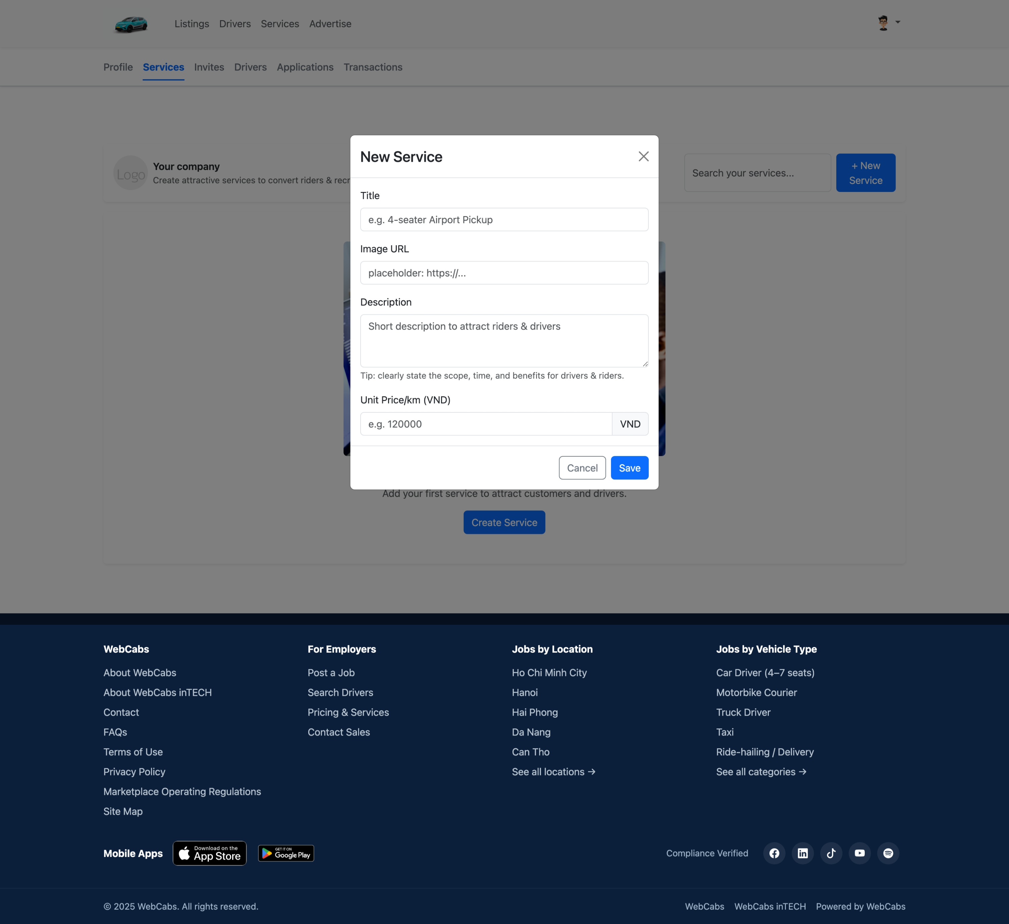

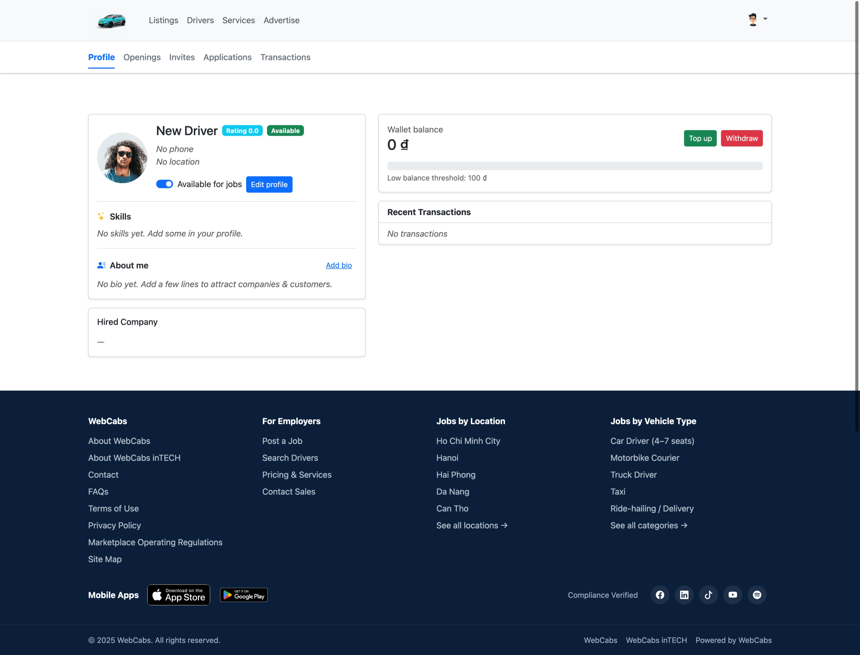

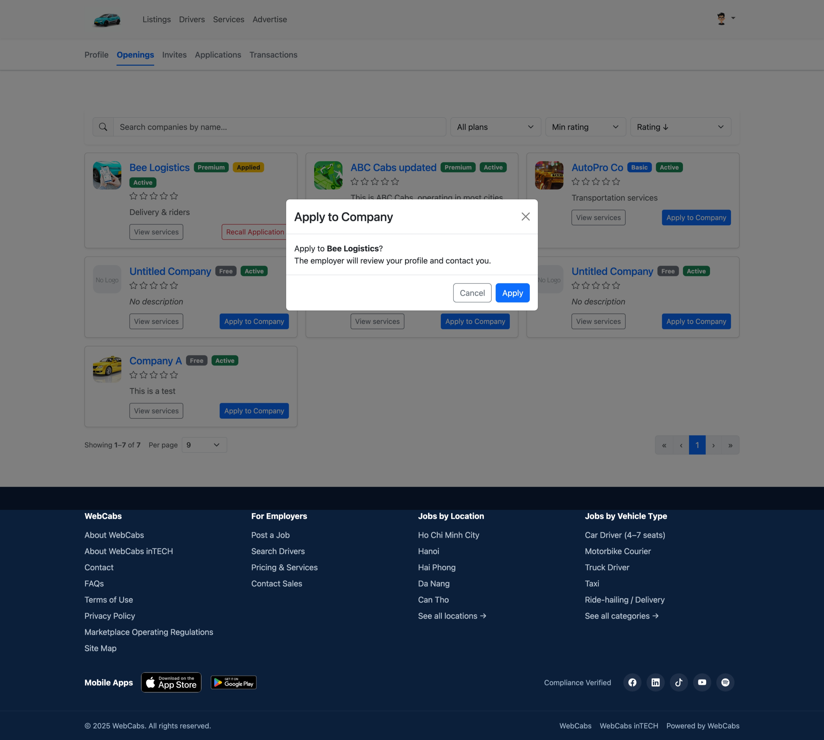

**7) Notifications v2 (Unread, Bulk, Soft delete)**

- Hub: /hubs/notifications (JWT via query ?access_token=...)  
- API: GET /api/notifications; GET /api/notifications/unread-count  
- Mark as read: POST /api/notifications/mark-read/{id} | mark-read-bulk | mark-all-read  
- Soft delete: DELETE /api/notifications/{id}  
- Realtime events: 'notification', 'unread_count'

**8) 1–1 Chat (reuse NotificationsHub)**

- API: POST /api/chat/threads, GET /api/chat/threads, GET /api/chat/threads/{id}/messages, POST /api/chat/threads/{id}/messages, POST /api/chat/threads/{id}/read, GET /api/chat/unread-count  
- Hub methods: JoinThread, LeaveThread, Typing  
- Realtime events: chat.message, chat.typing, chat.unread_total, chat.thread_unread

**9) Admin Dashboards**

- FE: /admin (requires role=Admin)  
- API: /api/admin/reports/overview | tx-daily | top-companies | top-drivers | low-wallets  
- Realtime: /hubs/admin emits 'admin:tx:new' when a new transaction occurs

**10) FE & Auth Configuration**

- Axios baseURL: VITE_API_BASE  
- Interceptor: attach Authorization: Bearer {accessToken}  
- After login: save token and redirect to /notifications  
- Navbar: shows unread badge via realtime updates

**11) Quick Testing (cURL samples)**

• OTP verify:  
 curl -X POST /api/otp/request {email,purpose}  
 curl -X POST /api/otp/verify {email,purpose,code}  
  
• Login:  
 curl -X POST /api/auth/login {email,password}  
 # returns accessToken  
  
• Admin overview:  
 curl -H "Authorization: Bearer <token>" /api/admin/reports/overview  
  
• Notifications unread count:  
 curl -H "Authorization: Bearer <token>" /api/notifications/unread-count

**12) Common Issues & Tips**

- Infinite 401 loop: FE does not auto-redirect, handle manually.  
- Role not accessing /admin: Ensure JWT has role=Admin and RoleClaimType is configured.  
- SignalR missing token: Pass ?access_token=... when connecting.  
- Company wallet insufficient: PaySalary/Membership returns Status=Failed if debit fails. Top-up wallet and retry.

**6. MyCabs – User Guide (FE & API)**

6.1 Auth

• POST /api/auth/register

• POST /api/auth/verify-otp

• POST /api/auth/login

Ghi chú: Resend OTP = Phase 2 (MVP chưa có endpoint riêng).

6.2 Admin

• POST /api/admin/users/{userId}/deactivate

Ghi chú: MVP chỉ deactivate user. Các target khác = Phase 2.

6.3 Companies

• GET /api/companies — List Companies

• GET /api/companies/{companyId} — Company Detail

• GET /api/companies/{companyId}/drivers — Company Drivers

• GET /api/companies/{companyId}/services/public — Public Services

• POST /api/companies/{companyId}/services — Create Service

• PUT /api/companies/{companyId}/services/{serviceId} — Update Service

• POST /api/companies/{companyId}/services/{serviceId}/pause — Pause Service

• POST /api/companies/{companyId}/services/{serviceId}/reactivate — Reactivate Service

• GET /api/companies/{id}/applications — List Job Applications

• POST /api/companies/{id}/applications/{appId}/approve — Approve Application

• POST /api/companies/{id}/applications/{appId}/reject — Reject Application

• GET /api/companies/{id}/invitations — List Invitations

• POST /api/companies/{id}/invitations — Send Invitation

• POST /api/companies/{id}/invitations/{inviteId}/cancel — Cancel Invitation

• POST /api/companies/{id}/pay-membership — Pay Membership

• POST /api/companies/{id}/pay-salary — Pay Salary

• GET /api/companies/{id}/transactions — Company Transactions

• GET /api/companies/{id}/wallet — Company Wallet

• POST /api/companies/{id}/wallet/topup — Wallet Top-up

• POST /api/companies/{id}/wallet/withdraw — Wallet Withdraw

• POST /api/companies/orders/{orderId}/confirm — Confirm Order

• POST /api/companies/orders/{orderId}/complete — Complete Order

Note: Review endpoints chưa public → chuyển sang Phase 2.

6.4 Drivers

• GET /api/drivers — Public Drivers

• GET /api/drivers/{userId} — Driver Profile (self)

• GET /api/drivers/{userId}/public — Driver Public Profile

• POST /api/drivers/{userId}/applications — Submit Application

• DELETE /api/drivers/{userId}/applications/{appId} — Cancel Application

• GET /api/drivers/{userId}/invitations — Invitations Received

• POST /api/drivers/{userId}/invitations/{inviteId}/accept — Accept Invitation

• POST /api/drivers/{userId}/invitations/{inviteId}/reject — Reject Invitation

• GET /api/drivers/{userId}/companies — Companies of Driver

• GET /api/drivers/{userId}/employment — Employment Info

• GET /api/drivers/{userId}/transactions — Driver Transactions

• GET /api/drivers/{userId}/wallet — Driver Wallet

• POST /api/drivers/{userId}/wallet/topup — Wallet Top-up

• POST /api/drivers/{userId}/wallet/withdraw — Wallet Withdraw

Note: Notifications/Chat = Phase 2.

6.5 Riders

• GET /api/riders — (optional public)

• GET /api/riders/{userId} — Rider Profile

• POST /api/riders/{userId}/orders — Create Order

• POST /api/riders/{userId}/orders/{orderId}/cancel — Cancel Order (Pending only)

• GET /api/riders/{userId}/orders — List Orders

• GET /api/riders/{userId}/orders/{orderId} — Order Detail

• GET /api/riders/{userId}/transactions — Rider Transactions

• GET /api/riders/{userId}/wallet — Rider Wallet

• POST /api/riders/{userId}/wallet/topup — Wallet Top-up

• POST /api/riders/{userId}/wallet/withdraw — Wallet Withdraw

Note: Reviews = Phase 2 (table có, endpoint chưa public).

6.6 Business Rules

• Orders: Rider chỉ được huỷ khi Pending; Company chỉ Complete từ InProgress.

• Wallet: Không cho âm số dư; cảnh báo khi balance_cents < low_balance_threshold.

• Membership: dùng companies.membership & membership_expires_at (không có store riêng).

• Quotas dịch vụ theo gói (Free=1, Basic=3, Premium=∞) — enforce tại Service Create.

6.7 Scope & Enums

• Phase 2: Reviews API, Notifications, Chat, Resend OTP chuyên biệt.

• Enums: invite_status, job_status, order_status, tx_status (đồng bộ như schema).